Alex Weisenbach

Christian Silva

The two links we primarily used to figure out how the ghost AI should work were <https://www.youtube.com/watch?v=ataGotQ7ir8> and <https://gameinternals.com/understanding-pac-man-ghost-behavior>. Based on these, we knew the general idea of the implementation of the AIs. The tinkering we did was primarily in movement and the fine details. We went through a few different iterations of the general movement, the first checking which direction it should go every frame. This mostly worked, except the ghosts could “turn around” by dipping into an intersection for a frame and then going the opposite way they were previously going. We then tried making the ghosts change after they had reached the next “tile” in the direction they were going, but that proved unreliable based on the framerate. Finally, we had the ghosts check for a new direction either when they had gone far enough from the previous location or couldn’t continue forward, which worked.

Beyond that, we fiddled with the distance from the ghost each direction was to be checked (as in, the points to be checked for distance to the target) until it reached what we wanted, and how each ghost’s target was placed in relation to Pac Man. The placements we ended up with felt pretty good, and fairly accurate to the original game.

For our custom algorithm, we simply made a perhaps more “realistic”, coordinated AI: each ghost targets one of a tile above, a tile below, a tile to the left, and a tile to the right of Pac Man. This leads to the ghosts drawing and closing a net around Pac Man. This algorithm is obviously much better for the ghosts, with the original algorithm being better for Pac Man. However, our custom algorithm is very little fun to play against, so it isn’t very good in the grand scheme of the game.

Below is the FSM for both the custom and original AI, with the active state differing between the two:

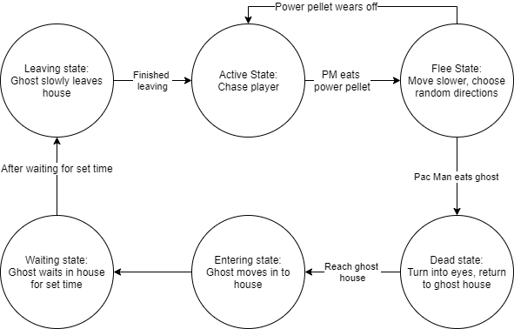

**Note:** To change between the two algorithms, simply go in to the prefab for each ghost and change the “Ghost Mode” variable from 1 (for original) to 2 (for custom) or vice versa.